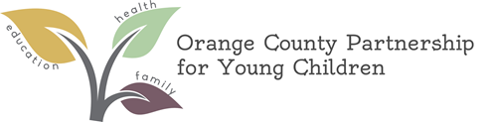

Board Calendar FY 25-26

All Board meetings are held on the last Wednesday of the month
from 8:30 to 10:00 a.m. (unless otherwise noted)

All Executive Committee meetings are held on the last Wednesday of the month
from 8:30 to 10:00 a.m. (unless otherwise noted)

Month | Type | Date | Location
August | Executive Committee | Wed., Aug. 27, 2025 | Virtual
September | Board | Wed., Sept. 24, 2025 | Durham Technical Community College, Orange County Campus  525 College Park Rd, Hillsborough, NC 27278, Room 105
October | Executive Committee | Wed., Oct. 29, 2025 | OCPYC Conference Room
November | Board | Wed., Nov. 19, 2025 | TBD
December | Executive Committee | Wed., Dec. 17, 2025 | OCPYC Conference Room
January | Board | Wed., Jan. 28, 2026 | TBD
February | Executive Committee | Wed., Feb. 25, 2026 | OCPYC Conference Room
March | Board | Wed., March 25, 2026 | TBD
April | Executive Committee | Wed., April 29, 2026 | OCPYC Conference Room
May | Board | Wed., May 27, 2026 | TBD
June | Executive Committee | Wed., June 24, 2026 | OCPYC Conference Room

